

**REPORT MANUAL OF JOBSHEET**

**Practicum, Tasks and Questions**

**(Network Programming)**

|  |  |  |  |  |
| --- | --- | --- | --- | --- |
|  | **Name** | **:** | **Brian Sayudha** |  |
|  | **Class / NIM** | **:** | **3G / 1841720158** |  |
|  | **Major** | **:** | **D-IV Informatics Enginering** |  |
|  |  |  |  |  |
|  |  |  |  |  |

Praktikum 1

Code

/*

 * To change this license header, choose License Headers in Project Properties.

 * To change this template file, choose Tools | Templates

 * and open the template in the editor.

 */

package filterStram_prak1;

import java.io.BufferedReader;

import java.io.IOException;

import java.io.InputStreamReader;

import java.util.logging.Logger;

import java.util.logging.Level;

public class *ReadInputKeyboard* {

    public static void main(*String*[] args) {

*BufferedReader* br = new *BufferedReader*(new *InputStreamReader*(System.in));

         System.out.println("Masukan karakter apapun, [tekan keluar tekan `q`]: ");

         char input = 0;

         do {

             try {

                 input = (char) br.read();

                 System.out.print("" + input);

             } catch (IOException ex) {

                 Logger.getLogger(ReadInputKeyboard.class.getName()).log(Level.SEVERE, null, ex);

             }

         } while (input != 'q');

    }

}

Output

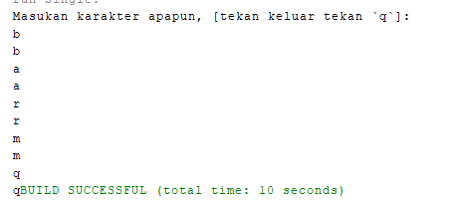

Question prak 1

1. Modifikasi program di atas sehingga dapat melakukan pembacaan text atau String!/*

 * To change this license header, choose License Headers in Project Properties.

 * To change this template file, choose Tools | Templates

 * and open the template in the editor.

 */

package filterStram_prak1;

import java.io.BufferedReader;

import java.io.IOException;

import java.io.InputStreamReader;

import java.util.logging.Logger;

import java.util.logging.Level;

public class *ReadInputKeyboard* {

    public static void main(*String*[] args) {

*BufferedReader* br = new *BufferedReader*(new *InputStreamReader*(System.in));

         System.out.println("Masukan karakter apapun, [tekan keluar ketik `quit`]: ");

*String* input = null;

         do {

             try {

                 input = br.readLine();

                 System.out.println("" + input);

             } catch (IOException ex) {

                 Logger.getLogger(ReadInputKeyboard.class.getName()).log(Level.SEVERE, null, ex);

             }

         } while (!input.equalsIgnoreCase("quit"));

    }

}

Output

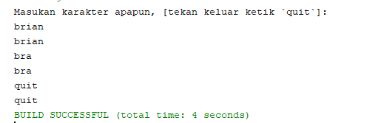

1. Mengapa try-catch diletakkan di dalam perulangan do-while?

Jawaban : Untuk memastikan bahwa apa yang kita inputkan itu benar dan menangkap error yang ada, dan pengecekan itu dilakukan setiap input dimasukkan

1. Silakan ubah kode di atas dengan memanfaatkan class selain BufferedReader, tetapi masih bisa membaca input melalui keyboard!

Jawaban :

/*

 * To change this license header, choose License Headers in Project Properties.

 * To change this template file, choose Tools | Templates

 * and open the template in the editor.

 */

package filterStram_prak1;

import java.io.BufferedReader;

import java.io.IOException;

import java.io.InputStreamReader;

import java.util.Scanner;

import java.util.logging.Logger;

import java.util.logging.Level;

public class *ReadInputKeyboard* {

    public static void main(*String*[] args) {

//         BufferedReader br = new BufferedReader(new InputStreamReader(System.in));

*Scanner* sc = new *Scanner*(System.in);

         System.out.println("Masukan karakter apapun, [tekan keluar ketik `quit`]: ");

*String* input = null;

         do {

             input = sc.nextLine();

             System.out.println("" + input);

         } while (!input.equalsIgnoreCase("quit"));

    }

}

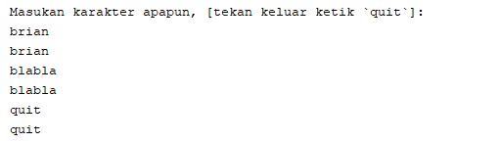

Praktikum 2

Code

/*

 * To change this license header, choose License Headers in Project Properties.

 * To change this template file, choose Tools | Templates

 * and open the template in the editor.

 */

package Praktikum3;

import Praktikum2.*;

import Praktikum1.*;

import Praktikum3.Praktikum3;

import java.awt.event.ActionEvent;

import java.awt.event.ActionListener;

import java.io.BufferedInputStream;

import java.io.BufferedOutputStream;

import java.io.BufferedReader;

import java.io.BufferedWriter;

import java.io.FileInputStream;

import java.io.FileNotFoundException;

import java.io.FileOutputStream;

import java.io.FileReader;

import java.io.FileWriter;

import java.io.IOException;

import java.io.InputStream;

import java.io.OutputStream;

import java.util.ArrayList;

import java.util.List;

import java.util.logging.Level;

import java.util.logging.Logger;

import javax.swing.JFileChooser;

import javax.swing.JOptionPane;

import javax.swing.text.BadLocationException;

import javax.swing.text.StyledDocument;

public class *Praktikum3Controller* {

    private *Praktikum3* view;

    private *List*<*Integer*> list = new *ArrayList*<>();

    public Praktikum3Controller(*Praktikum3* view) {

*this*.view = view;

*this*.view.getjButtonBaca().addActionListener(new *ActionListener*() {

            @Override

            public void actionPerformed(*ActionEvent* e) {

                proses();

            }

        });

*this*.view.getjButtonSimpan().addActionListener(new *ActionListener*() {

             @Override

             public void actionPerformed(*ActionEvent* e) {

                 save();

             }

         });

    }

     private void proses() {

*JFileChooser* loadFile = view.getLoadFile();

*StyledDocument* doc = view.getjTextPane().getStyledDocument();

             if (JFileChooser.APPROVE_OPTION == loadFile.showOpenDialog(view)) {

*BufferedInputStream* reader = null;

                 try {

                     reader = new *BufferedInputStream*(new *FileInputStream*(loadFile.getSelectedFile()));

                     doc.insertString(0, "", null);

                     int temp = 0;

*List*<*Integer*> list = new *ArrayList*<>();

                     while ((temp=reader.read()) != -1) {

                         list.add(temp);

                     }

                     if (!list.isEmpty()) {

                         byte[] dt = new byte[list.size()];

                         int i = 0;

                         for (Integer integer : list) {

                             dt[i]=integer.byteValue();

                             i++;

                         }

                         doc.insertString(doc.getLength(), new *String*(dt), null);

                         JOptionPane.showMessageDialog(view, "File berhasil dibaca.", "Informasi", JOptionPane.INFORMATION_MESSAGE);

                     }

                 } catch (FileNotFoundException ex) {

                     Logger.getLogger(Praktikum3Controller.class.getName()).log(Level.SEVERE, null, ex);

                 } catch (IOException | BadLocationException ex) {

                     Logger.getLogger(Praktikum3Controller.class.getName()).log(Level.SEVERE, null, ex);

                 } finally {

                     if (reader != null) {

                         try {

                             reader.close();

                         } catch (IOException ex) {

                             Logger.getLogger(Praktikum3Controller.class.getName()).log(Level.SEVERE, null, ex);

                         }

                     }

                 }

             }

     }

     private void save() {

*JFileChooser* loadFile = view.getLoadFile();

         if (JFileChooser.APPROVE_OPTION == loadFile.showSaveDialog(view)) {

*BufferedOutputStream* writer = null;

             try {

*String* contents = view.getjTextPane().getText();

                 if (contents != null && !contents.isEmpty()) {

                     writer = new *BufferedOutputStream*(new *FileOutputStream*(loadFile.getSelectedFile()));

                     writer.write(contents.getBytes());

                     JOptionPane.showMessageDialog(view, "File berhasil ditulis.", "Informasi", JOptionPane.INFORMATION_MESSAGE);

                 }

             } catch (FileNotFoundException ex) {

                 Logger.getLogger(Praktikum3Controller.class.getName()).log(Level.SEVERE, null, ex);

             } catch (IOException ex) {

                 Logger.getLogger(Praktikum3Controller.class.getName()).log(Level.SEVERE, null, ex);

             } finally {

                 if (writer != null) {

                     try {

                         writer.flush();

                         writer.close();

                         view.getjTextPane().setText("");

                     } catch (IOException ex) {

                         Logger.getLogger(Praktikum3Controller.class.getName()).log(Level.SEVERE, null, ex);

                     }

                 }

             }

         }

     }

}

Output

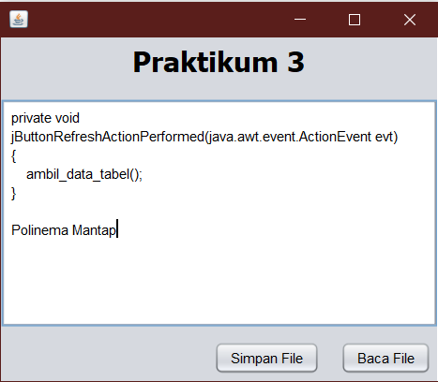

Question Prak 2

1. Sebuatkan perbedaan dari yang sebelumnya, ketika kode belum diubah selain dari sisi sintaks! Berikan argument Anda!

Jawaban = Dalam program baru ini, dalam pembacaan file sebuah code byte dapat diubah dalam bentuk string, dan kita bisa membaca dan mengeditnya menjadi sesuatu yang baru

1. Pada kode di atas, proses baca menggunakan fungsi read(), silakan diubah menggunakan read(byte b[]) atau read(byte b[], int off, int len). Jalankan kembali hasil perubahan yang Anda lakukan!

Jawaban : jika kita menambahkan itu maka untuk pembacaan dilakukan pembatasan sesuai dengan len dari byte array offset yang ada

1. Pada kode di atas, proses tulis menggunakan fungsi write(byte b[]), silakan diubah menggunakan write(byte b) atau write(byte b[], int off, int len). Jalankan kembali hasil perubahan yang Anda lakukan!

Maka dalam proses menulis len bytes dari spesifik data yang dimulai dari offset kepada buffered output stream

Tugas 1

Design

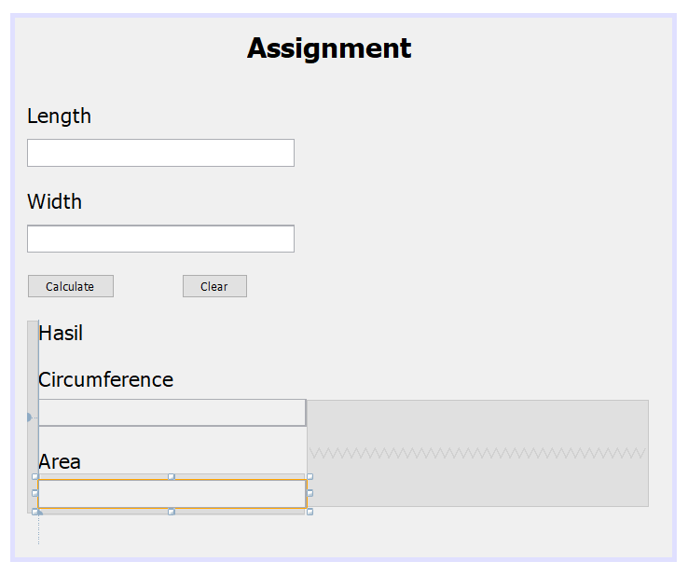

Code

Calc.java (to calculate the area)

/*

 * To change this license header, choose License Headers in Project Properties.

 * To change this template file, choose Tools | Templates

 * and open the template in the editor.

 */

package filter*S*tream_tugas;

/**

 *

 * @author Asus

 */

public class calc {

    private *double* length;

    private *double* width;

    private final luasCalc view;

    public calc(*luasCalc* *view*) {

*this*.view = view;

    }

    public *double* getArea(){

*String* strLength=view.getPanjang().getText();

*String* strWidth=view.getLebar().getText();

*this*.length = Double.valueOf(strLength);

*this*.width = Double.valueOf(strWidth);

        return length * width;

    }

    public *double* getCircumference(){

*String* strLength=view.getPanjang().getText();

*String* strWidth=view.getLebar().getText();

*this*.length = Double.valueOf(strLength);

*this*.width = Double.valueOf(strWidth);

        return (2*length)+(2*width);

    }

}

Logging.java (to print error)

/*

 * To change this license header, choose License Headers in Project Properties.

 * To change this template file, choose Tools | Templates

 * and open the template in the editor.

 */

package filter*S*tream_tugas;

import java.io.FileNotFoundException;

import java.io.PrintStream;

import java.util.logging.Logger;

import java.util.logging.Level;

public class logging {

    luasCalc view;

    public static *PrintStream* output;

    public static *PrintStream* outputErr;

    public static *boolean* isError;

    public logging(*luasCalc* *view*) {

*this*.view = view;

        try {

            output=**new** PrintStream("Log.log");

            outputErr = **new** PrintStream("Log.err");

        } catch (*FileNotFoundException* *ex*) {

            Logger.getLogger(logging.class.getName()).log(Level.SEVERE, null, ex);

        }

    }

    public *void* setLog(*String* *message*){

        output.println(message);

    }

    public *void* setLogErr(*String* *message*){

        outputErr.println(message);

    }

}

Jframe code

/*

 * To change this license header, choose License Headers in Project Properties.

 * To change this template file, choose Tools | Templates

 * and open the template in the editor.

 */

package filter*S*tream_tugas;

import java.awt.HeadlessException;

import java.util.Calendar;

import javax.swing.JButton;

import javax.swing.JFileChooser;

import javax.swing.JOptionPane;

import javax.swing.JTextField;

import javax.swing.JTextPane;

/**

 *

 * @author Asus

 */

public class luasCalc extends javax.swing.*JFrame* {

    private calc controller;

    private logging logs;

    /**

     * Creates new form luas_calc

     */

    public luasCalc() {

        initComponents();

        controller = **new** calc(*this*);

        logs = **new** logging(*this*);

    }

    public *JTextField* getPanjang() {

        return panjangtxt;

    }

    public *JTextField* getLebar() {

        return lebartxt;

    }

//

    /**

     * This method is called from within the constructor to initialize the form.

     * WARNING: Do NOT modify this code. The content of this method is always

     * regenerated by the Form Editor.

     */

    @*SuppressWarnings*("unchecked")

    // <editor-fold defaultstate="collapsed" desc="Generated Code">

    private *void* initComponents() {

        jLabel1 = **new** javax.swing.JLabel();

        jLabel2 = **new** javax.swing.JLabel();

        jLabel3 = **new** javax.swing.JLabel();

        jLabel4 = **new** javax.swing.JLabel();

        panjangtxt = **new** javax.swing.JTextField();

        lebartxt = **new** javax.swing.JTextField();

        calculatebtn = **new** javax.swing.JButton();

        clearbtn = **new** javax.swing.JButton();

        jPanel1 = **new** javax.swing.JPanel();

        jLabel5 = **new** javax.swing.JLabel();

        jLabel6 = **new** javax.swing.JLabel();

        jLabel7 = **new** javax.swing.JLabel();

        keliling = **new** javax.swing.JTextField();

        jLabel8 = **new** javax.swing.JLabel();

        area = **new** javax.swing.JTextField();

        jLabel1.setFont(**new** java.awt.Font("Tahoma", 1, 24)); // NOI18N

        jLabel1.setText("Praktikum 3");

        setDefaultCloseOperation(javax.swing.WindowConstants.EXIT_ON_CLOSE);

        jLabel2.setFont(**new** java.awt.Font("Tahoma", 1, 24)); // NOI18N

        jLabel2.setText("Assignment ");

        jLabel3.setFont(**new** java.awt.Font("Tahoma", 0, 18)); // NOI18N

        jLabel3.setText("Length");

        jLabel4.setFont(**new** java.awt.Font("Tahoma", 0, 18)); // NOI18N

        jLabel4.setText("Width");

        panjangtxt.addActionListener(**new** java.awt.event.ActionListener() {

            public *void* actionPerformed(java.awt.event.ActionEvent evt) {

                panjangtxtActionPerformed(evt);

            }

        });

        lebartxt.addActionListener(**new** java.awt.event.ActionListener() {

            public *void* actionPerformed(java.awt.event.ActionEvent evt) {

                lebartxtActionPerformed(evt);

            }

        });

        calculatebtn.setText("Calculate");

        calculatebtn.addActionListener(**new** java.awt.event.ActionListener() {

            public *void* actionPerformed(java.awt.event.ActionEvent evt) {

                calculatebtnActionPerformed(evt);

            }

        });

        clearbtn.setText("Clear");

        jLabel5.setFont(**new** java.awt.Font("Tahoma", 0, 18)); // NOI18N

        jLabel5.setText("Hasil");

        jLabel6.setFont(**new** java.awt.Font("Tahoma", 0, 18)); // NOI18N

        jLabel6.setText("Circumference");

        jLabel7.setFont(**new** java.awt.Font("Tahoma", 0, 18)); // NOI18N

        keliling.setEditable(false);

        keliling.addActionListener(**new** java.awt.event.ActionListener() {

            public *void* actionPerformed(java.awt.event.ActionEvent evt) {

                kelilingActionPerformed(evt);

            }

        });

        jLabel8.setFont(**new** java.awt.Font("Tahoma", 0, 18)); // NOI18N

        jLabel8.setText("Area");

        area.setEditable(false);

        area.addActionListener(**new** java.awt.event.ActionListener() {

            public *void* actionPerformed(java.awt.event.ActionEvent evt) {

                areaActionPerformed(evt);

            }

        });

*javax*.*swing*.*GroupLayout* jPanel1Layout = **new** javax.swing.GroupLayout(jPanel1);

        jPanel1.setLayout(jPanel1Layout);

        jPanel1Layout.setHorizontalGroup(

            jPanel1Layout.createParallelGroup(javax.swing.GroupLayout.Alignment.LEADING)

            .addGroup(jPanel1Layout.createSequentialGroup()

                .addContainerGap()

                .addGroup(jPanel1Layout.createParallelGroup(javax.swing.GroupLayout.Alignment.LEADING)

                    .addComponent(jLabel5)

                    .addComponent(jLabel6)

                    .addComponent(jLabel7)

                    .addComponent(keliling, javax.swing.GroupLayout.PREFERRED_SIZE, 230, javax.swing.GroupLayout.PREFERRED_SIZE)

                    .addComponent(jLabel8)

                    .addComponent(area, javax.swing.GroupLayout.PREFERRED_SIZE, 230, javax.swing.GroupLayout.PREFERRED_SIZE))

                .addContainerGap(294, Short.MAX_VALUE))

        );

        jPanel1Layout.setVerticalGroup(

            jPanel1Layout.createParallelGroup(javax.swing.GroupLayout.Alignment.LEADING)

            .addGroup(jPanel1Layout.createSequentialGroup()

                .addComponent(jLabel5)

                .addGap(18, 18, 18)

                .addComponent(jLabel6)

                .addPreferredGap(javax.swing.LayoutStyle.ComponentPlacement.RELATED)

                .addComponent(keliling, javax.swing.GroupLayout.PREFERRED_SIZE, 24, javax.swing.GroupLayout.PREFERRED_SIZE)

                .addGap(18, 18, 18)

                .addComponent(jLabel8)

                .addPreferredGap(javax.swing.LayoutStyle.ComponentPlacement.RELATED, javax.swing.GroupLayout.DEFAULT_SIZE, Short.MAX_VALUE)

                .addComponent(area, javax.swing.GroupLayout.PREFERRED_SIZE, 24, javax.swing.GroupLayout.PREFERRED_SIZE)

                .addPreferredGap(javax.swing.LayoutStyle.ComponentPlacement.RELATED)

                .addComponent(jLabel7)

                .addGap(70, 70, 70))

        );

*javax*.*swing*.*GroupLayout* layout = **new** javax.swing.GroupLayout(getContentPane());

        getContentPane().setLayout(layout);

        layout.setHorizontalGroup(

            layout.createParallelGroup(javax.swing.GroupLayout.Alignment.LEADING)

            .addGroup(layout.createSequentialGroup()

                .addGroup(layout.createParallelGroup(javax.swing.GroupLayout.Alignment.LEADING)

                    .addGroup(layout.createSequentialGroup()

                        .addGap(199, 199, 199)

                        .addComponent(jLabel2))

                    .addGroup(layout.createSequentialGroup()

                        .addContainerGap()

                        .addComponent(jLabel3))

                    .addGroup(layout.createSequentialGroup()

                        .addContainerGap()

                        .addComponent(jLabel4))

                    .addGroup(layout.createSequentialGroup()

                        .addContainerGap()

                        .addComponent(panjangtxt, javax.swing.GroupLayout.PREFERRED_SIZE, 230, javax.swing.GroupLayout.PREFERRED_SIZE))

                    .addGroup(layout.createSequentialGroup()

                        .addContainerGap()

                        .addComponent(lebartxt, javax.swing.GroupLayout.PREFERRED_SIZE, 230, javax.swing.GroupLayout.PREFERRED_SIZE))

                    .addGroup(layout.createSequentialGroup()

                        .addContainerGap()

                        .addGroup(layout.createParallelGroup(javax.swing.GroupLayout.Alignment.LEADING)

                            .addGroup(layout.createSequentialGroup()

                                .addComponent(calculatebtn)

                                .addGap(58, 58, 58)

                                .addComponent(clearbtn))

                            .addComponent(jPanel1, javax.swing.GroupLayout.PREFERRED_SIZE, javax.swing.GroupLayout.DEFAULT_SIZE, javax.swing.GroupLayout.PREFERRED_SIZE))))

                .addContainerGap(20, Short.MAX_VALUE))

        );

        layout.setVerticalGroup(

            layout.createParallelGroup(javax.swing.GroupLayout.Alignment.LEADING)

            .addGroup(layout.createSequentialGroup()

                .addContainerGap()

                .addComponent(jLabel2)

                .addGap(33, 33, 33)

                .addComponent(jLabel3)

                .addPreferredGap(javax.swing.LayoutStyle.ComponentPlacement.UNRELATED)

                .addComponent(panjangtxt, javax.swing.GroupLayout.PREFERRED_SIZE, 24, javax.swing.GroupLayout.PREFERRED_SIZE)

                .addGap(18, 18, 18)

                .addComponent(jLabel4)

                .addPreferredGap(javax.swing.LayoutStyle.ComponentPlacement.UNRELATED)

                .addComponent(lebartxt, javax.swing.GroupLayout.PREFERRED_SIZE, 24, javax.swing.GroupLayout.PREFERRED_SIZE)

                .addGap(18, 18, 18)

                .addGroup(layout.createParallelGroup(javax.swing.GroupLayout.Alignment.BASELINE)

                    .addComponent(calculatebtn)

                    .addComponent(clearbtn))

                .addGap(18, 18, 18)

                .addComponent(jPanel1, javax.swing.GroupLayout.PREFERRED_SIZE, 194, javax.swing.GroupLayout.PREFERRED_SIZE)

                .addContainerGap(javax.swing.GroupLayout.DEFAULT_SIZE, Short.MAX_VALUE))

        );

        pack();

    }// </editor-fold>

    private *void* panjangtxtActionPerformed(*java*.*awt*.*event*.*ActionEvent* *evt*) {

        // TODO add your handling code here:

    }

    private *void* lebartxtActionPerformed(*java*.*awt*.*event*.*ActionEvent* *evt*) {

        // TODO add your handling code here:

    }

    private *void* calculatebtnActionPerformed(*java*.*awt*.*event*.*ActionEvent* *evt*) {

*String* logMessage="";

*Calendar* cal = Calendar.getInstance();

        try{

            if(!panjangtxt.getText().isEmpty() && !lebartxt.getText().isEmpty()){

*String* length=panjangtxt.getText();

*String* width = lebartxt.getText();

*String* check= length+width;

*boolean* isNumber=true;

                for(*char* c:check.toCharArray()){

                    if((c>='a'&&c<='z')||(c>='A'&&c<='Z')){

                        isNumber=false;

                        logMessage = cal.getTime()+" | Operation Error\nOperation with non numeric value";

                        logs.setLogErr(logMessage);

                        JOptionPane.showMessageDialog(rootPane, "Length and Width field should be a Number value", "Error", JOptionPane.ERROR_MESSAGE);

                        break;

                    }

                }

                if(isNumber){

                    if(Integer.valueOf(length)<=0 || Integer.valueOf(width)<=0){

                        logMessage = cal.getTime()+" | Operation Error\nInvalid input number. Zero operation Error";

                        logs.setLogErr(logMessage);

                        JOptionPane.showMessageDialog(rootPane, "Invalid input number of zero operation.","Error",JOptionPane.ERROR_MESSAGE);

                    }else{

*this*.area.setText(String.valueOf(controller.getArea()));

*this*.keliling.setText(String.valueOf(controller.getCircumference()));

                        logMessage = cal.getTime()+" | Operation Fine\nRectangle "+panjangtxt.getText()+" x "+lebartxt.getText()+" | Area = "+controller.getArea()+" - Perimeter = "+controller.getCircumference();

                        logs.setLog(logMessage);

                    }

                }

            }else{

                logMessage = cal.getTime()+" | Operation Warning\nOperation with empty Length or Width field";

                logs.setLogErr(logMessage);

                JOptionPane.showMessageDialog(rootPane, "Length and Width field should not be empty", "Warning", JOptionPane.WARNING_MESSAGE);

            }

        }catch(*HeadlessException* *ex*){

        }

    }

    private *void* kelilingActionPerformed(*java*.*awt*.*event*.*ActionEvent* *evt*) {

        // TODO add your handling code here:

    }

    private *void* areaActionPerformed(*java*.*awt*.*event*.*ActionEvent* *evt*) {

        // TODO add your handling code here:

    }

    /**

     * @param *args* the command line arguments

     */

    public static *void* main(*String* *args*[]) {

        /* Set the Nimbus look and feel */

        //<editor-fold defaultstate="collapsed" desc=" Look and feel setting code (optional) ">

        /* If Nimbus (introduced in Java SE 6) is not available, stay with the default look and feel.

         * For details see http://download.oracle.com/javase/tutorial/uiswing/lookandfeel/plaf.html

         */

        try {

            for (*javax*.*swing*.*UIManager*.*LookAndFeelInfo* info : javax.swing.UIManager.getInstalledLookAndFeels()) {

                if ("Nimbus".equals(info.getName())) {

                    javax.swing.UIManager.setLookAndFeel(info.getClassName());

                    break;

                }

            }

        } catch (*ClassNotFoundException* *ex*) {

            java.util.logging.Logger.getLogger(luasCalc.class.getName()).log(java.util.logging.Level.SEVERE, null, ex);

        } catch (*InstantiationException* *ex*) {

            java.util.logging.Logger.getLogger(luasCalc.class.getName()).log(java.util.logging.Level.SEVERE, null, ex);

        } catch (*IllegalAccessException* *ex*) {

            java.util.logging.Logger.getLogger(luasCalc.class.getName()).log(java.util.logging.Level.SEVERE, null, ex);

        } catch (*javax.swing.UnsupportedLookAndFeelException* *ex*) {

            java.util.logging.Logger.getLogger(luasCalc.class.getName()).log(java.util.logging.Level.SEVERE, null, ex);

        }

        //</editor-fold>

        //</editor-fold>

        /* Create and display the form */

        java.awt.EventQueue.invokeLater(**new** Runnable() {

            public *void* run() {

**new** luasCalc().setVisible(true);

            }

        });

    }

    // Variables declaration - do not modify

    private *javax*.*swing*.*JTextField* area;

    private *javax*.*swing*.*JButton* calculatebtn;

    private *javax*.*swing*.*JButton* clearbtn;

    private *javax*.*swing*.*JLabel* jLabel1;

    private *javax*.*swing*.*JLabel* jLabel2;

    private *javax*.*swing*.*JLabel* jLabel3;

    private *javax*.*swing*.*JLabel* jLabel4;

    private *javax*.*swing*.*JLabel* jLabel5;

    private *javax*.*swing*.*JLabel* jLabel6;

    private *javax*.*swing*.*JLabel* jLabel7;

    private *javax*.*swing*.*JLabel* jLabel8;

    private *javax*.*swing*.*JPanel* jPanel1;

    private *javax*.*swing*.*JTextField* keliling;

    private *javax*.*swing*.*JTextField* lebartxt;

    private *javax*.*swing*.*JTextField* panjangtxt;

    // End of variables declaration

}